**11/12** 

**Contemporary Philippine Arts from the Regions**

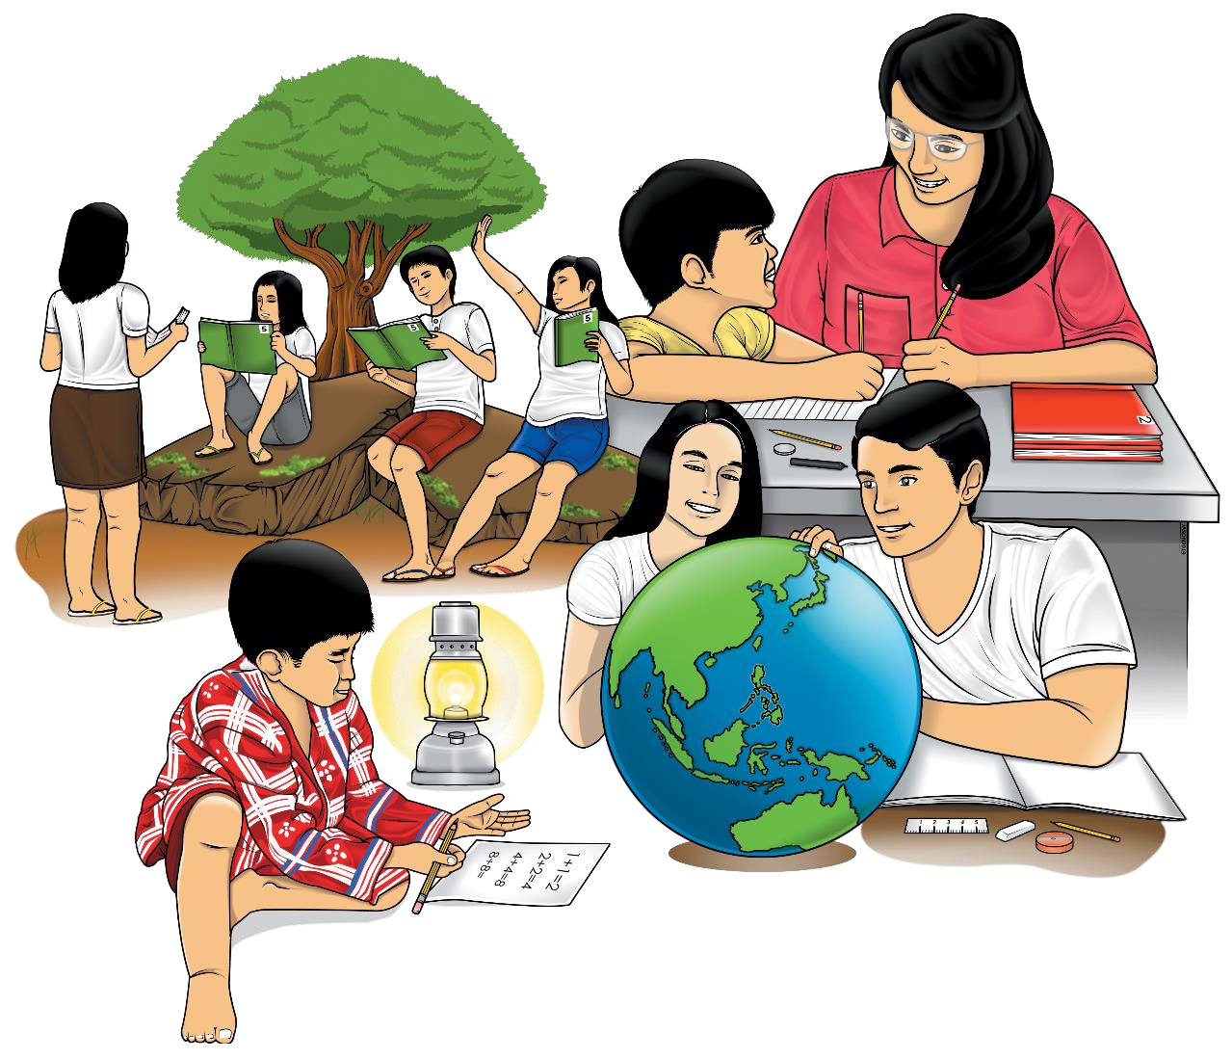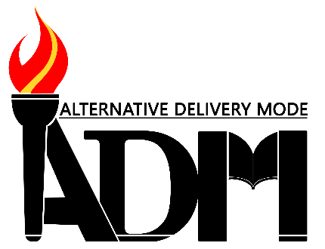

**Quarter 2 – Module 5-6**

**Lesson 1. Conceptualize Contemporary Art Based on Techniques and Performance Practices**

**Lesson 2. Artistic Skills and Techniques**

**Contemporary Philippine Arts from the Region – Grade 11 /12**

**Alternative Delivery Mode**

**Quarter 2– Module 3: Lesson 1. Conceptualize Contemporary Art Based on Techniques and Performance Practices**

**Lesson 2. Artistic Skills and Techniques**

**First Edition, 2020**

**Republic Act 8293, section 176** states that: No copyright shall subsist in any work of the Government of the Philippines. However, prior approval of the government agency or office wherein the work is created shall be necessary for exploitation of such work for profit. Such agency or office may, among other things, impose as a condition the payment of royalties.

Borrowed materials (i.e., songs, stories, poems, pictures, photos, brand names, trademarks, etc.) included in this module are owned by their respective copyright holders. Every effort has been exerted to locate and seek permission to use these materials from their respective copyright owners. The publisher and authors do not represent nor claim ownership over them.

Published by the Department of Education, Tagbilaran City Division

Secretary: SDS

Undersecretary: ASDS Marcelo K. Palispis, Ed.D.

|  |
| --- |
| **Development Team of the Module**  **Writer/s:** Rochelle Margaret C. Real  Faustino Rey T. Hormiguera  Dennis L. Bigcas  **Editors:** Rochelle Margaret C. Real  Faustino Rey T. Hormiguera  Dennis L. Bigcas  **Reviewers:** Vincent Mark P. Ranay  Alberto A. Lacang  **Management Team:**  SDS Joseph Irwin A. Lagura, Ed.D  Division CID Chief John Ariel A. Lagura, PhD  Division EPS In charge of LRMDS Neolita S. Sarabia, PhD |

**Printed in the Philippines by**

**Department of Education – Region VII | Tagbilaran City Schools Division**

Office Address: Raha Sikatuna St., Dampas , Tagbilaran City Bohol, Philippines 6300 Telephone Nos. (038)427-1702; (038)427-2506

E-mail Address: dtagbilarandivision@yahoo.com

# 11/12

**Contemporary Philippine Arts**

**From the Region**

**Quarter 1 – Module 3**

**Lesson 1. Conceptualize Contemporary Art Based on Techniques and Performance Practices**

## Lesson 2. Artistic Skills and Techniques

FAIR USE AND CONTENT DISCLAIMER: This SLM (Self Learning Module) is for educational purposes only. Borrowed materials (i.e., songs, stories, poems, pictures, photos, brand names, trademarks, etc.) included in these modules are owned by their respective copyright holders. The publisher and authors do not represent nor claim ownership over them. Sincerest appreciation to those who have made significant contributions to these modules.



**Introductory Message**

For the facilitator:

Welcome to the Contemporary Philippine Arts from Region -11/12 Alternative Delivery Mode (ADM) Module Defining Contemporary Art!

This module was collaboratively designed, developed and reviewed by educators both from public and private institutions to assist you, the teacher or facilitator in helping the learners meet the standards set by the K to 12 Curriculum while overcoming their personal, social, and economic constraints in schooling.

This learning resource hopes to engage the learners into guided and independent learning activities at their own pace and time. Furthermore, this also aims to help learners acquire the needed 21st century skills while taking into consideration their needs and circumstances.

In addition to the material in the main text, you will also see this box in the body of the module:

***Notes to the Teacher***

This contains

helpful tips or strategies

that

will

help you in guiding the learners.



As a facilitator you are expected to orient the learners on how to use this module. You also need to keep track of the learners' progress while allowing them to manage their own learning. Furthermore, you are expected to encourage and assist the learners as they do the tasks included in the module.

For the learner:

Welcome to the Contemporary Philippine Arts from Region-11/12 Alternative Delivery Mode (ADM) Module on **Defining Contemporary Art**!

The hand is one of the most symbolized part of the human body. It is often used to depict skill, action and purpose. Through our hands we may learn, create and accomplish. Hence, the hand in this learning resource signifies that you as a learner is capable and empowered to successfully achieve the relevant competencies and skills at your own pace and time. Your academic success lies in your own hands!

This module was designed to provide you with fun and meaningful opportunities for guided and independent learning at your own pace and time. You will be enabled to process the contents of the learning resource while being an active learner.

This module has the following parts and corresponding icons:

|  |  |  |  |
| --- | --- | --- | --- |
| |  |  | | --- | --- | | C:\Users\DEPED\Desktop\ADM specs\ADM cover and icons\ADM Icons\Alamin2.jpg | ***What I Need to Know*** | | This will give you an idea of the skills or competencies you are expected to learn in the module. |
| |  |  | | --- | --- | | C:\Users\DEPED\Desktop\ADM specs\ADM cover and icons\ADM Icons\What I Know.jpg | ***What I Know*** | | This part includes an activity that aims to check what you already know about the lesson to take. If you get all the answers correct (100%), you may decide to skip this module. |
| |  |  | | --- | --- | | C:\Users\DEPED\Desktop\ADM specs\ADM cover and icons\ADM Icons\Balikan.jpg | ***What’s In*** | | This is a brief drill or review to help you link the current lesson with the previous one. |
| |  |  | | --- | --- | | C:\Users\DEPED\Desktop\ADM specs\ADM cover and icons\ADM Icons\Tuklasin.jpg | ***What’s New*** | | In this portion, the new lesson will be introduced to you in various ways such as a story, a song, a poem, a problem opener, an activity or a situation. |
| |  |  | | --- | --- | | C:\Users\DEPED\Desktop\ADM specs\ADM cover and icons\ADM Icons\suriin.jpg | ***What is It*** | | This section provides a brief discussion of the lesson. This aims to help you discover and understand new concepts and skills. |
| |  |  | | --- | --- | | C:\Users\DEPED\Desktop\ADM specs\ADM cover and icons\ADM Icons\whats more.jpg | ***What’s More*** | | This comprises activities for independent practice to solidify your understanding and skills of the topic. You may check the answers to the exercises using the Answer Key at the end of the module. |
| |  |  | | --- | --- | | C:\Users\DEPED\Desktop\ADM specs\ADM cover and icons\ADM Icons\Isaisip.jpg | ***What I Have Learned*** | | This includes questions or blank sentence/paragraph to be filled in to process what you learned from the lesson. |
| |  |  | | --- | --- | | C:\Users\DEPED\Desktop\ADM specs\ADM cover and icons\ADM Icons\Isagawa.jpg | ***What I Can Do*** | | This section provides an activity which will help you transfer your new knowledge or skill into real life situations or concerns. |
| |  |  | | --- | --- | | C:\Users\DEPED\Desktop\ADM specs\ADM cover and icons\ADM Icons\Tayahin.jpg | ***Assessment*** | | This is a task which aims to evaluate your level of mastery in achieving the learning competency. |
| |  |  | | --- | --- | | C:\Users\DEPED\Desktop\ADM specs\ADM cover and icons\ADM Icons\Additional Activities.jpg | ***Additional Activities*** | | In this portion, another activity will be given to you to enrich your knowledge or skill of the lesson learned. This also tends retention of learned concepts. |
| |  |  | | --- | --- | | C:\Users\DEPED\Desktop\ADM specs\ADM cover and icons\ADM Icons\Answer Key 2.jpg | ***Answer Key*** | | This contains answers to all activities in the module. |

At the end of this module you will also find:

|  |  |
| --- | --- |
| ***References*** | This is a list of all sources used in developing this module. |

The following are some reminders in using this module:

1. Use the module with care. Do not put unnecessary mark/s on any part of the module. Use a separate sheet of paper in answering the exercises.
2. Don’t forget to answer *What I Know* before moving on to the other activities included in the module.
3. Read the instruction carefully before doing each task.
4. Observe honesty and integrity in doing the tasks and checking your answers.
5. Finish the task at hand before proceeding to the next.
6. Return this module to your teacher/facilitator once you are through with it.

If you encounter any difficulty in answering the tasks in this module, do not hesitate to consult your teacher or facilitator. Always bear in mind that you are not alone.

We hope that through this material, you will experience meaningful learning and gain deep understanding of the relevant competencies. You can do it

### What I Need to Know

This module was designed and written with you in mind. It is here to help you describes various contemporary art forms and their practices from the various regions.. The scope of this module permits it to be used in many different learning situations. The language used recognizes the diverse vocabulary level of students. The lessons are arranged to follow the standard sequence of the course. But the order in which you read them can be changed to correspond with the textbook you are now using.

Most Essential Learning Competency:

* Conceptualize contemporary arts based on techniques and performance practices in their locality (CAR11/12TPP-0c-e-14
* Applies artistic skills and techniques in the process of creation. CAR11/12TPP-0c-e-15

At the end of this module, you should be able to:

* Recognize the different arts and crafts in their locality
* Identify the different skills and techniques of art.
* Applies artistic skills and techniques in the process of creation.
* Conceptualize contemporary arts based on techniques and performance practices in their locality.

### What I Know

**Pre-Test**

**MULTIPLE CHOICE**.Write the letter of the correct answer from the choices.

1. __________ is defined as the material or the substance out of which a work is made.

A. Artistic Skills C. Medium

B. Technique D. Natures of Art

1. Which of the following is classified as “two-dimensional” art?

A. Pottery C. Paintings

B. Sculpture D. Installation art

1. The following uses “words” as a medium for making art EXCEPT ________.

A. Nonfiction C. Sculpture

B. Novel D. Poetry

1. These are the abilities that are possessed by artists who operate within a fine art capacity.

A. Artistic Skills C. Mediums

B. Techniques D. Natures of Art

1. These are how artists use and manipulate materials to achieve the desired formal effect, and communicate the desired concept, or meaning, according to his or her style

A. Artistic Skills C. Mediums

B. Techniques D. Natures of Art

1. This is a technique of rubbing with a crayon on a piece of paper that has been placed over an object or an image.

A. Decoupage C. Frottage

B. Trapunto D. Graffiti

1. The French word “Decollage” in English means _______________.

A. Take-off C. Arrange

B. To glue together D. To stuck

1. It is an art form that is created in nature, using natural materials such as soil and rock.

A. Land Art C. Mixed Media

B. Graffiti D. Trapunto Painting

1. Digital Artworks are made with _____________.

A. digital technology C. natural materials

B. pigments D. assemblage of different forms

1. _______ is the process of applying gouache to paper or glass then transferring a reversal of the image onto canvas or other flat materials.

A. Decalcomania C. Print Making

B. Frottage D. Collage

|  |  |
| --- | --- |
|  |  |

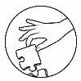

### What’s In

In the previous module, we looked closely at the forms of artwork, and we saw how materials, techniques, and elements can be capable of conveying concepts, values feelings and attitudes. We have viewed, experienced and sensed works of art closely, and heightened and honed our senses in the process.

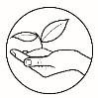In practice, it is difficult to separate subject matter and thematic plane. Subject matter answers the question “what do we see, hear, smell, taste, or touch?” Using our senses is the initial step, and as we learned in the previous lessons of this module, this requires keen and diligent observation, not just of the image, but how it is presented and if there is no image, how the formal elements are employed.

### What’s New

***ACTIVITY 1: OBSERVE***

Observe the photo below. Write five (5) sentences on what you have observed.

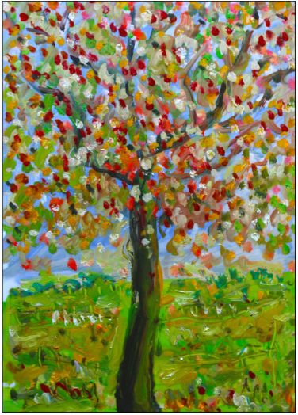

https://bit.ly/36ePUU0

1. _________________________________________________________________
2. _________________________________________________________________
3. _________________________________________________________________
4. _________________________________________________________________
5. _________________________________________________________________

|  |  |  |
| --- | --- | --- |
| |  |  | | --- | --- | | C:\Users\DEPED\Desktop\ADM specs\ADM cover and icons\ADM Icons\suriin.jpg | ***What is It*** |   Each province in the Philippines can proudly boast of its arts and crafts. For example, Bohol have enriched their local arts and crafts. Some of the arts and crafts of Bohol includes the following:   * Basket weaving in Antequera * Tubigon Loom Weaving Center-has become a tour stop where visitors witness actual loom weaving. * Bolo-making in Loay * Bolo-making and pottery in Albur * Jewelry-making in Dauis * Furniture-making in Loboc   Arts and crafts in Bohol are being learned by local residents in the province. Local residents treat their arts and crafts as a source of income, making it an entrepreneurship.  Bohol is a province in Visayas that is found in Central Visayas (Cebu, Bohol, Siquijor and Negros Oriental). Bohol is known for its "Sandugo Festival" celebrated every month of July. This festival commemorates the Treaty of Friendship between Datu Sikatuna, a chieftain in Bohol, and Spanish conquests Miguel Lopez de Legaspi.  **PHILIPPINE ART HISTORY:** |

|  |  |
| --- | --- |
|  |  |

**ARTISTIC SKILLS AND TECHNIQUES**

With the broadening of the art world, many people are getting confused about what qualifies as an artistic skill. **Artistic skills** are abilities that are possessed by artists who operate within a fine art capacity.

Each artist uses different mediums to develop their artistic skills example the sculptor uses metal, wood, stone and glass in sculpting same also the architect uses wood, bamboo, bricks stone etc. in architecture and many more. A medium is defined as the material, or the substance out of which a work is made. Through these materials, the artists express and communicate feelings and ideas. It is already mentioned in the previous modules that the medium also defines the nature of the art forms

**Technique** is the way artists use and manipulate materials to achieve the desired formal effect, and communicate the desired concept, or meaning, according to his or her personal style (modern, Neoclassic, etc.). The distinctive character or nature of the medium determines the technique.

Technique involves tools and technology, ranging from most traditional (for example carving, silkscreen, analog photography, and filmmaking) to the most contemporary (digital photography, digital filmmaking, music production, industrial design, and robotics).

Here are some of art techniques used by artists.

1. **Collage** – is the technique of an art production used in the visual arts where the artwork is made from on assemblage of different forms, thus creating a new whole. Collage may sometimes include magazines and newspaper clippings, ribbons, paints, bits of colored or handmade papers, portions of other artwork or texts, photographs, and other found objects, glued to a piece of paper or canvas.
2. **Decollage** – is the opposite of collage; instead of an image is being built up all or parts of existing images, it is created by cutting, treating away or otherwise removing pieces of an original image. The French word “Decollage” in English means “Take-off” or “To become Unglued” or “To become unstuck”. Example of decollage include cut-up technique. Similar technique is the lacerated poster, a poster in which one has been over another.
3. **Graffiti** – are writing or drawings that have been scribed, scratched, or painted illicitly on a wall or other surface, often in a public space. Graffiti range from

simple written words to elaborate wall paintings. Graffiti may express underlying social and political messages, and a whole genre of artistic expression is based on spray paint graffiti styles.

1. **Land Art** – earthworks, or earth arts is an art movement in which landscape and the work of art are inextricably linked. It is also an art form that is created in nature, using natural materials such as soil, rock (bed rock, boulders, stones), organic media (logs, branches, leaves), and water which introduced materials such as concrete, metal asphalt, or mineral pigments.
2. **Digital Arts** – is an artistic work or practice that uses digital technology as an essential part of the creative or presentation process. Digital art is work made with digital technology or presented on digital technology. This includes images done completely on a computer or hand-drawn images scanned into a computer and finished using a software program like Adobe Illustrator. Digital art can also involve animation and 3D virtual sculpture renderings as well as projects that combine several technologies. Some digital art involves the manipulation of video images. After some resistance, the impact of digital technology has transformed activities such as paintings, drawing, sculpture, and music/sound art, while new forms such as net art.
3. **Mixed Media** – It refers to a work of visual art that combines various traditionally distinct visual art. For example, work on canvas that combines paint, ink and collage. When creating a painted or photograph work using mixed media, it is important to choose the layers carefully and allow enough dying time between the layers to ensure the final work will have structural integrity, if many different layers are imposed. Many effects can be achieved by using mixed media. Found objects can be used in conjunction with the traditional artist to attain a wide range of self-expression.
4. **Print Making** – is the process of making artworks by painting, normally in the paper. Prints are created by transforming ink from a matrix ink from a matrix or through a prepared screen to a sheet of paper or other material. Common types of matrices include metal plates, usually copper or zinc, or polymer plates for engraving or etching; stone aluminum of polymer for lithography; blocks of wood crafts and wood graving; and linoleum for linocuts. Screen made of silk or synthetic fabrics are used for the screen-printing process.
5. **Frottage** – is the technique of rubbing with crayon on a piece of paper which has been placed over an object or an image. The impression of the image can be created using leaves, woods, wire screen, or metal with embossed image or words.
6. **Decalcomania** – is the process of applying gouache to paper or glass then transferring a reversal of the image onto canvas or other flat materials.
7. **Decoupage** – is done by adhering cut-outs of paper and then coating these with one or transparent coating of varnish.
8. **Eggshell mosaic** - is an artistic technique that uses tiny parts of eggshell to create a whole image or object. Mosaics are usually assembled using small tiles that are square, but they can also be round or randomly shaped.
9. **Trapunto painting** – is the technique used by Pacita Abad where her canvases are padded, sewn, and often filled with sequins, beads, shell, buttons, tiny mirrors, bits of glass, rickrack, swatches of precious textiles and other things that she picks up from her travels and journey.

Art is considered an “artifact’ when it is directly experienced and perceived. It can be spatial and static or unmoving (a painting or building, or novel) or time based and in motion (a live theater production and mobile sculpture).

To know the full meaning of a work, it is also necessary to study the material from which it is made and how it is made.

|  |  |
| --- | --- |
|   **COLLAGE**  https://bit.ly/352o7XH |   **LAND ARTS**  https://bit.ly/3p1GVhl |

|  |  |
| --- | --- |
|   **PRINT MAKING**  https://bit.ly/38gkH5F |   **EGGSHELL MOSAIC**  https://bit.ly/36pls8X |

|  |  |
| --- | --- |
| **DIGITAL ARTS**  https://bit.ly/2TVRBAa | **GRAFFITI**  https://bit.ly/36cQJfZ |
|   **MIXED MEDIA**  https://bit.ly/3198pzy |   **DECOLLAGE**  https://bit.ly/3k5pV6z |

|  |  |
| --- | --- |
|   **FROTTAGE**  https://bit.ly/353xG8T | **DECALCOMANIA**  https://bit.ly/3euxwKK |
| **DECOUPAGE**  https://bit.ly/2U3CRis |   **TRAPUNTO PAINTING**  https://bit.ly/3p1GVhl |

|  |  |
| --- | --- |
| C:\Users\DEPED\Desktop\ADM specs\ADM cover and icons\ADM Icons\whats more.jpg | ***What’s More*** |

**ACTIVITY 2: LET’S IMAGINE!**

Imagine you are going to have an art exhibit that will stage in a major mall in your place. Answer the guide questions below to create a concept of your art exhibit.

Guide questions:

1. What artistic skill/s should I use?

______________________________________________________________________________________________________________________________________________

1. What technique/s should I use?

______________________________________________________________________________________________________________________________________________

1. How big or small is my exhibit? Should I display it inside or outside the mall?

______________________________________________________________________________________________________________________________________________

1. Should I open my art exhibit to public? ________________________________________________________________________________________________________________________________________________
2. Should I open my art exhibit to the public?

________________________________________________________________________

|  |  |
| --- | --- |
| C:\Users\DEPED\Desktop\ADM specs\ADM cover and icons\ADM Icons\Isaisip.jpg | ***What I Have Learned*** |

**ACTIVITY 3: GAIN INSIGHTS**

Answer the questions below to summarize what you have learned in this lesson.

* What do you think is the most recent among the techniques mentioned in this lesson?
* How would you differentiate collage from decollage?
* Where else do you see graffiti?
* Have you seen one land art? What is it made of?

|  |  |
| --- | --- |
| C:\Users\DEPED\Desktop\ADM specs\ADM cover and icons\ADM Icons\Isagawa.jpg | ***What I Can Do*** |

**ACTIVITY 4: BODY PAINTING**

Draw or paint an image or picture that symbolize your zodiac sign on a part of your body, or on your model either on the face, hands or legs. Use henna powder or any washable painting materials. Take a picture and paste on the box provided.

|  |  |
| --- | --- |
| C:\Users\DEPED\Desktop\ADM specs\ADM cover and icons\ADM Icons\Tayahin.jpg | ***Assessment*** |

**Post-Test**

**Multiple Choice.** Select the letter of the best answer from among the given choices.

1. _______ is the process of applying gouache to paper or glass then transferring a reversal of the image onto canvas or other flat materials.

A. Decalcomania C. Print Making

B. Frottage D. Collage

1. The material, or the substance out of which a work is made is called __________.

A. Artistic Skills C. Medium

B. Technique D. Natures of Art

1. The abilities that are possessed by artists who operate within a fine art capacity.

A. Artistic Skills C. Mediums

B. Techniques D. Natures of Art

1. Which of the following is not classified as “three-dimensional” art?

A. Pottery C. Paintings

B. Sculpture D. Installation art

1. Most of the digital Artworks are made with _____________.

A. digital technology C. natural materials

B. pigments D. assemblage of different forms

1. An art form using soil and rock is called _________.

A. Land Art C. Mixed Media

B. Graffiti D. Trapunto Painting

1. The following uses “words” as a medium for making art expect ________.

A. Nonfiction C. Sculpture

B. Novel D. Poetry

1. The manner in which artists use and manipulate materials to achieve the desired formal effect, and communicate the desired concept, or meaning, according to his or her personal style

A. Artistic Skills C. Mediums

B. Techniques D. Natures of Art

1. A technique of rubbing with crayon on a piece of paper placed over an object or an image is called __________.

A. Decoupage C. Frottage

B. Trapunto D. Graffiti

1. What is the English term for “Decollage”?

A. Take-off C. Arrange

B. To glue together D. To stuck

**Answer Key**

**Pre - Test Post Test**

1. C 1. A
2. C 2. C
3. C 3. A
4. A 4. C
5. B 5. A
6. C 6. A
7. A 7. C
8. A 8 . B
9. A 9. C
10. A 10. a

**What’s New (Activity 1: Observe)**

*depends on learner’s answer*

**What’s More (Activity 2: Imagine)**

*depends on learner’s answer*

**What I Have Learned (Activity 3: Gain Insights)**

*depends on learner’s answer*

**What I Can Do (Activity 4:Body Painting)**

**\*** use rubric

**Rubric for Grading Art Project**

|  |  |  |  |
| --- | --- | --- | --- |
| Points | Creativity/ Originality | Effort/ Perseverance | Craftsmanship/skill |
| 4 | The student explored several choices before selecting one, generated many ideas, tried unusual combination or changes, used problem-solving skills. | The project was continued until it was complete as the student could make it; gave it effort far beyond that required. | The artwork was  beautiful and patiently done; it was good as hard work could make it. |
| 3 | The student tried a few ideas before selecting one or based his/her work on someone else’s idea, made decision after referring to one source. | The student worked hard and completed the project, but with a  bit more effort it might  have been outstanding. | With a little more effort, the work could have been outstanding; lacks the finishing touches. |
| 2 | The student tried an idea but it lacked originally, might have copied work, and substituted “symbols” for personal expression. | The student finished the project, but it could have been improved with more effort, chose an easy project and did it differently. | The student showed average craftsmanship; adequate, but not as good as it could have been, a bit careless. |
| 1 | The student fulfilled the requirements of the assignment, but gave no evidence of trying anything unusual | the project was completed with minimum effort | The student showed average craftsmanship, lack of pride in finished work |
| 0 | The student showed no evidence of original thought | The student did not finish the work adequately | The student showed poor craftsmanship; evidence of laziness or lack of understanding |

**References**

“Indigenous Artists Who Have Kept Filipino Creativity Alive.” CNN. Accessed July 30, 2020. https://cnnphilippines.com/life/culture/2017/10/10/indigenous-artists-national-living-treasures.html.

“Order of National Artists.” National Commission for Culture and the Arts.

Accessed July 30, 2020.

https://ncca.gov.ph/about-culture-and-arts/culture-profile/national-artists-of-the-philippines/.

“Recognizing the Stranger: The Art of Emmanuel Garibay.” Image Journal, August 25, 2016. https://imagejournal.org/article/recognizing-the-stranger/.

“Chromolithography.” Omeka RSS. Accessed July 30, 2020. https://americanantiquarian.org/prang/whatisachromo.

Doroteja August, November 16, kanak November 19, chris August 17, Maleko August 17, Judy Fischer Walton August 18, Thomas Ahlswede August 18, et al. “Use The Hidden Meaning of Color In Your Art.” Fine Art Tips & The 2020 Club with Lori McNee, April 17, 2020.

https://www.finearttips.com/2009/08/use-the-hidden-meaning-of-color-in-your-art/.

Pinterest.com. *"The Buzzed Artist, Helping You Art With Confidence,"*

https://www.pinterest.ph/pin/586805026422139320/

Snopes Media Group In., *"Did a Sperm Whale Die After Swallow After 64 Pound Debris?,"*

Published April 12, 2018

https://www.snopes.com/fact-check/sperm-whale-die-swallowing-64-pounds-plastic- debris/

Laib, Wolfgang. "Word Press.com" *"Art Using Pollen,"*

https://discosaurus.files.wordpress.com/2010/04/laib_pollen6.jpg

Mashed Potatoes and Crafts *"Art Using Pollen,"* Crafted May 15, 2013.

http://www.mashedpotatoesandcrafts.com/2013/05/dyed-rice-mosaic.html

Pinterest.com. *"14 Awesome Works of Art Made Entirely From Stones That Will Leave You*

*Impressed,"*

https://www.pinterest.ph/pin/303007881177977751/

**For Inquiries or feedback, please write or call:**

Department of Education – Bureau of Learning Resources (DepEd-BLR)

DepEd Tagbilaran City Schools Division

Raha Sikatuna, Dampas, Tagbilaran City

Telephone: (038)427-1702; (038)427-2506

E-mail Address: dtagbilarandivision@yahoo.com